**1. Introduction to Shaoyang University**

Founded in 1958, Shaoyang University is a provincially-owned comprehensive undergraduate institution with approval from the Ministry of Education to enroll both master’s degree graduate students and international students. The university is located in Shaoyang City, Hunan Province, a famous cultural city with a history of more than 2,500 years.

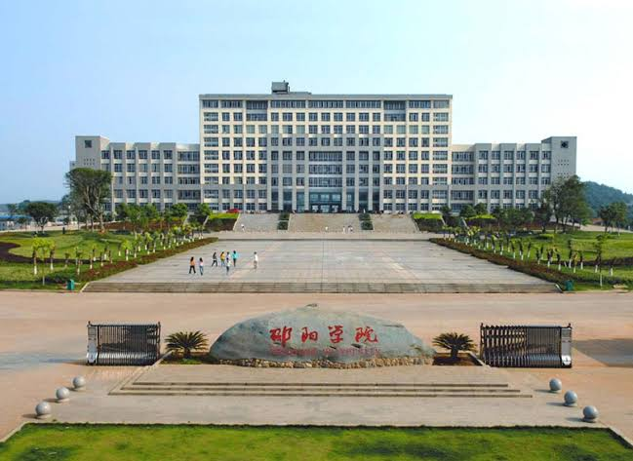

**2.Enrollment Plan**

One-year language training students:

1) Non-Chinese citizens who abide by Chinese laws and school regulations, study seriously, and are in good health.

(2) Language students should be between 18 and 30 years old and have a high school diploma or equivalent education. You can apply for the Hunan Province Language Student Scholarship from countries along the Belt and Road and the on-campus Class A scholarship.

**3.Application materials:** 1. "Foreign Student Admission Application Form" (see attachment 1, the application form must be filled in by the applicant); 2. A copy of the information page of your ordinary passport (in principle, the passport must be valid for more than one year after admission) ; 3. Scanned copy of highest academic certificate or notarized Chinese/English translation (with official seal); "Physical Examination Form for Foreigners" valid within 6 months Certificate of no criminal record or a notarized Chinese/English translation (applicants must submit a valid certificate of no criminal record issued by the local public security authority, valid within 6 months); 7. Bank deposit certificate (held for one year) Proof of deposit equivalent to the tuition fee and sufficient to cover reasonable expenses such as study and living expenses during the period of studying in China); 8. Self-introduction video (no more than 1 minute in length, in mp4 format, with a capacity of less than 40MB, degree students must use Chinese, and send it to Mail);