**Majors:**New Energy Science and Engineering，Civil Engineering，Food Science and Engineering，Electrical Engineering and Automation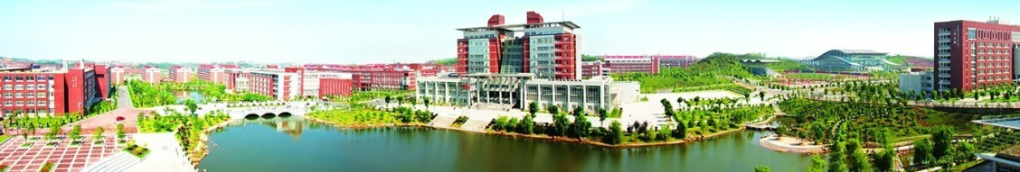

**Additional Majors:**Business Administration，Human Resource Management，Transportation Engineering，Computer Science and Technology  
**Basic Eligibility Requirements for Applicants:**

Applicants must be non-Chinese citizens;

Applicants must be in good physical and mental health, with good academic and moral standing;Educational background and age requirements:  
(1) Applicants for undergraduate programs must have a high school diploma and be under the age of 25;  
(2) Applicants for master’s degree programs must hold a bachelor’s degree and be under the age of 35;  
(3) Applicants for doctoral degree programs must hold a master’s degree and be under the age of 40;  
(4) Applicants under the age of 18 must submit a notarized letter of authorization signed by their guardian in China.

**Scholarship**

Silk Road Scholarship